28th Annual Newsletter

(2004-2005)

Department of Biological Sciences

Sam Houston State University

HOMECOMING!
Celebrate Homecoming with us on Saturday, October 8, 2005

Homecoming Activities

(See http://www.shsu.edu/homecoming/ for details of SHSU Homecoming)

Wednesday, October 5
7:00 pm Homecoming Parade- Sam Houston Avenue
Friday, October 7
6:00 pm Distinguished Alumni Gala- LSC Ballroom
Saturday, October 8
10:30 am Dedication of Campus Bell Tower
10:00 am College of Arts and Sciences Open House- Lee Drain Building
11:00 am Pre-game with the President- Austin Hall
12 noon SHSU Tailgate Bearkat Alley- Bowers Stadium parking lot
2:00 pm Football Game SHSU vs. Northwestern State -Bowers Stadium

5:00 p.m. Department of Biological Sciences Homecoming Barbecue, rain or shine, at the home of Dr. Jimmie Long, 3352 Winter Way, Spring Lake Subdivision (located one mile west of I-45 on FM 1374). Sponsored by Department faculty and staff. No charge.
The newsletter is still under construction. Check back for additional entries in the next few days. You may still submit your personal information to be included in this year’s edition of the newsletter by sending information to bio_aad@shsu.edu or bio_mlt@shsu.edu (posted 10/3/05).

News from the Chairs
From Dr. Monte Thies
As the saying goes, “Time flies when you’re having fun”. It’s hard to believe that five years have passed already since I became chair of Biological Sciences. It has been an interesting (and busy) five years, and time for me to step down and turn the chair’s responsibilities over to Dr. Matthew Rowe. Dr. Rowe comes to SHSU following 20+ years at Appalachian State University, a sister institution also strongly dedicated to undergraduate education, and I look forward to working with him in the future in both the classroom and the field.

Over the past five years, the department has seen a number of changes, some good and some perhaps not so good, but we have never departed from our primary mission as educators. University enrollments have increased to new records, and Biology has grown rapidly. With this growth, we have been able to add one new faculty position (filled by Dr. Rowe) with two more tenure track positions to be filled this year; however, we have received no additional space so our faculty and students are doing more teaching and research in the same amount of space. Fortunately, support has been good as has been our quest for outside funding. It was a good year for recognition of professional excellence, with Diane Neudorf and the Cooks awarded tenure and promoted to Associate Professor. Jack Turner and I were also promoted to Full Professor. Tami and Jerry Cook have an NSF biodiversity grant to study insect parasite diversity in the Big Thicket, and Diane Neudorf and Bill Lutterschmidt just completed their second summer’s NSF undergraduate research experience on the field station. I led a project that was funded by the US Air Force to develop a campus lab intended to survey areas along the Texas/Mexico border for mosquitoes carrying West Nile Virus.

Following five years dedicated primarily to administration, I am looking forward to increasing my teaching and research activities, and spending more time developing facilities and programs at the Center for Biological Field Studies. As chair, three students complete their Masters degrees under my supervision and I continued grant writing and research activities that led to a number of publications and presentations at regional and national meetings, supervised two summer undergraduate research projects, and provided advisement support for countless students. We have a proposal currently pending that (if approved) would provide the funds necessary to build an education center on the field station.

As chair of the pre-professional advising program, we have also had decent success with our students continuing on to professional programs. Not all report back as to where they were accepted, but notable students for this year include Joshua Stringer and Megan Becker going to UTMB-Galveston, Phillip Laughlin to St. Georges Medical School, and Aimee Stark and Patsy Winder starting veterinary school at Texas A&M. If you were accepted into a professional program, know someone who was, or simply have news that you would like to share with the department and your fellow Biology/Environmental Science alumni, let us know! We want to hear from you!

From Dr. Matthew P. Rowe
I am both humbled and excited by the responsibilities I recently assumed as new chair of the Department of Biological Sciences at Sam Houston State University. I am humbled because I know a bit of the history of the Department, which has been well served by a long line of outstanding teachers, scholars, chairs, and graduates. The academic foundations that our retired faculty and past students helped build here at SAM are strong. I am humbled as well by the talent and dedication demonstrated by our current faculty, staff, and students – their commitment to excellence is palpable, and their enthusiasm infectious. I am unabashedly excited about the Department, about our students, and about our collective future.

That is not to say that we don’t face challenges, and the problems are not trivial. At the University level, our challenges are the product of past successes -- an exponential growth in student enrollment unmatched by any increase in the size or number of our classrooms, research labs, equipment budgets, etc. Class sizes are skyrocketing, and the quality of the educational experience we can deliver is being compromised. At the national level, challenges scale from the physically tiny, such as the spreading West Nile virus, to the immense, including restoration of the salt marshes needed to protect coastal cities from future category 5 hurricanes. And at the planetary level, even an abbreviated list of the challenges we face appears overwhelming; e.g., global warming, AIDS, internecine conflicts, soil erosion, collapse of our pelagic fisheries, biodiversity loss, the emergence of antibiotic-resistant super-germs ……. Solutions to many of these problems will require imaginative and integrative problem solvers with training in the sciences, most notably the life sciences.

Why am I excited rather than daunted by these challenges? Because, the faculty and the staff in the Department of Biological Sciences at Sam Houston State University are an outstanding group, collectively committed to training the next generation of problem solvers. By combining exemplary teaching with a passionate devotion to scientific discovery, they are literally infecting our students with a love of learning, with an appreciation for life in all its diverse forms, and with a desire to be part of the solution, not part of the problem. This Department cares deeply about its students, literally taking to heart H.G. Wells’ statement that “civilization is a race between education and catastrophe.” We have a lot of hard work ahead of us, but we will succeed. I am proud to be part of this team.

Now, if we could just convince the SHSU Administration and the Texas State legislature of our desperate need for a new, state-of-the-art, well equipped, “green” Biology building.

Dr. Matthew Rowe
Professor and Chair

News of Graduates

Scott Bosworth (BS 1999 BIO) works for the North Carolina Wildlife Resources Commission. He does surveys of the state’s non-mammalian vertebrates. He and his wife have a one year old daughter and live near Ashville, NC

Courtney Alexander (BS 2001 BIO) completed Dental School at the UT Health Sciences Center in San Antonio in the spring of 2005. Her plans included a summer wedding and entering private dental practice in San Antonio. She is applying for a residency in pediatric dentistry which is a two year program starting in June of 2006.

Edward (Ned) Sekinger (BS 1991, MA 1994) reported in June that upon completion of his Post-doctoral position at Harvard Medical School, he accepted a position as Senior Scientist at the biotech firm, Ambion, in Austin, TX. In his note to Dr. Dewees, he had this to say: “I often reflect back on my academic years and can honestly say "I have enjoyed my education". It has been memorable with some of my most fond memories being of SHSU, the people I met, and my guidance from you. Sometimes I wish I could re-live those years...they were truly life altering.”

Vaishali Parikh Casanova (BS 1996 BIO) is in her third year of residency in family practice at the Conroe Regional Medical Center. Her husband Edward is beginning a residency in psychiatry at Texas Tech Medical School. They are the proud parents of a son, Izak, born in March of 2005.

Daniella Ayala (BS 2003 BIO) is attending Physical Therapy School at UTMB in Galveston, TX.

Megan Becker (BS 2004 BIO) was accepted into the UTMB Medical School in 2005.

Kyla Beguesse (BS 2005 BIO) is now attending graduate school at Tuskegee University in Tuskegee, AL.

Sian Escobar (BS 2003 BIO) is working on an MS degree in Biology at SHSU. She is doing her thesis research with Dr. Diane Neudorf in paternity testing in Carolina Wrens.

Kristi Chock (BS 2005 BIO) was accepted into the Physical Therapy program at UTMB in Galveston, TX. She began the program in the fall of 2005.

Stacey Black (BS 2001 BIO) received her MD degree from UTMB in Galveston and is now in training as a flight surgeon at the Naval Air Station in Pensacola, FL.

Scott Domonoski (BS 2001 BIO) is in his second year in the Physicians Assistant program at the UT Southwestern Medical Center in Dallas.

Heather Elfman (BS 2004 BIO) is attending graduate school at the UT School of Public Health in Houston.

Melissa Layton (BS 2001, MS 2005 BIO) began a PhD program in biology at Texas A&M University this fall semester.

Philip Laughlin (BS 2004 BIO) is attending medical at St Georges University in Granada.

Nathan Liles (BS 2001 BIO) is completing his fourth year of medical school at UTMB in Galveston, TX.

Johnathan McEwen (BS 1998 BIO), who has been working at Lexicon Genetics in The Woodlands for the past seven years, began dental school this fall at UT Houston.

The following BIO graduates of the Department are attending the School of Veterinary Medicine at Texas A&M University in College Station: Kelly D’Orazio (MS 2003), Brad Bennett (MS 2000), Virginia Snell (MS 2003), Aimee Stark (BS 2003), Jana Story (BS 2001), and Patsy Winder (BS 2004).

Brandy Nunez (BS 2005 BIO) began working toward the MS degree in Biology at SHSU this fall semester.

Sara Turk (BS 2000, MS 2003 BIO) is in the PhD program in the Department of Physiology at the Kansas Medical Center in Kansas City, KS.

Angela Venn (BS 2004 BIO) began the PhD program in Biomedical Sciences at the University of Alabama at Birmingham this fall.

Brandi Verhalen (BS 2005 BIO) entered the Ph. D. program in cell biology at the State University of New York at Syracuse.

Barbara Jean Ford (BS 1999 ESC) works for the U. S. Government as a Sustainability Management System Coordinator at Fort Bragg, NC. She reports that she enjoys her work and career. In a note to Dr. DeShaw, she writes “I would like to thank you and the other professors in the environmental science department for giving me the education and knowledge that has allowed me to build such a rewarding career.”

Chris Norch (BS 1989 BIO) is residing in Sherman Texas with his wife Brooke, a certified physician’s assistant, and their two children, Logan (10) and Lauren (5). Chris is employed as President of Denison Industries, a premium aluminum casting and machining operation servicing the automotive, aerospace and defense industries.

Kelly Spahr (BS 2000 ESC) made a career change this spring, leaving a position at Sigma-Genosys to enter science teaching. He is enrolled in an alternative certification program, and says that “I think teaching is in my blood and I know that I would excel at it.”

Pat Taylor (MA 1972 BIO) is in her 33rd year as an instructor in the Biology Department at Blinn College in Brenham, TX. She teaches courses in Human A&P, zoology and general biology. She reports that “I still enjoy birding.” Other graduates in Biology at SHSU who are currently serving on the biology teaching faculty at Blinn College include Colleen Biles (BA 1996, MS 2002), Leon Wooten (BA 1973, MS 1985), Greg Phillips (MA 1983), and Dudley Latimer (BS 1974, MS 1977).

Donna Busby (BS 1995 ESC) completed an MS degree at State University of New
York - College of Environmental Science and Forestry back in May 2004. In a recent note to Dr. DeShaw, Donna reports “I finally started a great job in Southeastern Connecticut. I'm working with a Tribal Natural Resources group as a water quality tech. The Tribe, the Mashantucket Peqouts, have a 6,000 acre reservation and a very large casino (Foxwoods). My role is mainly surface and groundwater monitoring.

Walter “Buddy” Anderson (BS 1970’s BIO) recently retired from his dental practice. While at SHSU, Buddy was a place kicker for the Bearkat football team. Currently, he is a Head Referee for the National Football League.

Allison Orosco (BS BIO 2004) is currently working for the United States Air Force as a Research Analyst at the AFRL at Brooks City Base, TX. She has been accepted into the MSPH in Parasitology program at Tulane School of Public Health and Tropical Medicine in New Orleans, LA for the Spring 2006 semester.

TriBeta News

Last spring at the 40th anniversary initiation, ten students were initiated as full members including Tyra Blackshear, Mallory Brodrick, Sabrina Dahlgren, Brandy Dalton, Shara Dluhos, Jacquelyn Loeve, Tracy Lostak, Carlye Schulte, David Stork and Amanda Alfred. Eleven new associate members were initiated including Lisa Broussard, monica Carmona, Juan Garcia, Kaitlen Gary, Heather Gonzales, Amanda Lucas, Amber Mendoza, Jenna Rausheck, Maiko Uga, Ryan Williamson and Candace Wise. Dr. Ted Brummel and Dr. Anne Guillard were initiated as honorary faculty.

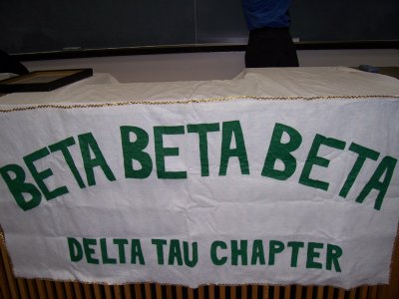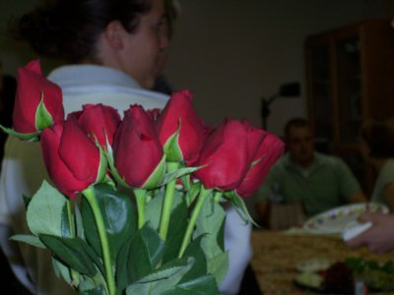

Our banner and initiation would not be complete without red roses.

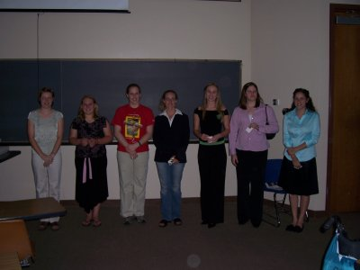

New members: Tyra Blackshear, Mallory Brodrick, Sabrina Dahlgren, Brandy Dalton, Shara Dluhos, Jacquelyn Loeve, Tracy Lostak, Carlye Schulte

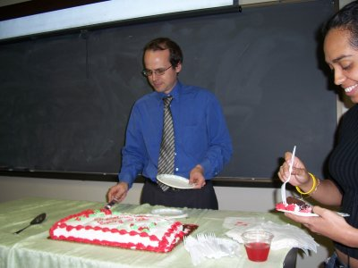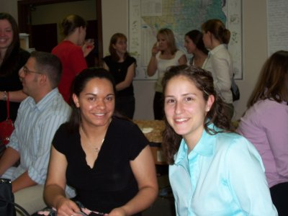

Dr. Ted Brummel, our new geneticist, serving cake at the reception
New members, Candice Wise and Carlye Schulte at the reception.

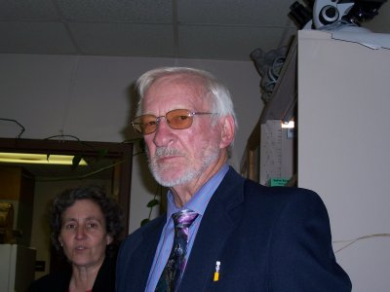
Dr Wilson at the reception.
Dr. Wilson was one of the twenty-three individuals who applied for the original SHSU tri beta charter which was granted on the 5th March 1965. Also included on the charter were Lannie Cardona, Polly Cozier, Jack Diehl, Baldemar Garcia, Milton Huettel, Novalene Imler, Sharon Knight, Herschel Knippa Jr., Michael Lisano, Leona Longmire, Patricia Mangum, Ronald McKown, Nancy Moore, James Olive, Richard Orts, Jolene Renfro, Lynda Voswinkle, Jon Watson, Jack Whitescarver, Maynard Yoes, James Long and Ruth Thomas.

During the fall and spring semesters, TriBeta offered free tutoring for students in the Freshman Biology classes. Brandy Verhalen did an outstanding job with this service project and many students benefited from the tutoring.
Submitted by Dr. Joan Hudson, faculty TriBeta sponsor

S.H.A.M.O.S

The Sam Houston Association of Medically Oriented Students (S.H.A.M.O.S.), also known as the meds club, is offered to any student interested in pursuing a career in the medical field. Through experience, SHAMOS members assist each other with some of the obstacles of a pre-professional student. Some of our bi-annual events include fundraisers, community service projects, a blood drive with the Gulf Coast Regional Blood Center, the meds club picnic, and a canned food drive. In the past year, we have had speakers from the fields of: radiology, occupational therapy, forensic pathology, and EMS. With the University, we have been involved with homecoming events, Saturday at Sam, and the Bearkat Attack. We have club meetings and officer meetings twice a month to keep updated with our 42 members (still growing) and our calendar of events. Dr. Karölis Bagdonas, our very supportive faculty advisor, has been with the club for sixteen years and is very active with the club. This semester we are hoping to do some volunteer work for Texas Children’s Hospital and also to see some autopsies performed, along with our other activities. Questions or comments - SHAMOS_shsu@lycos.com

Biological Sciences Graduate Student Organization

The graduate students in the Department of Biological Sciences have joined together to form the Biological Sciences Graduate Student Organization (BSGSO). Our mission is to promote and support academic and social activities of interest to graduate students, and to serve as a liaison between the graduate students, faculty, and staff. We whole-heartedly believe that our efforts to strengthen the quality of graduate education within the Department are not only integral to the Department’s success, but will contribute as well to the growing national reputation of our programs.

The BSGSO has been active this semester and has already begun to improve student/faculty relations. We have asked the faculty to permit graduate student representation on certain committees (e.g., job searches, graduate studies), to which they have graciously agreed. We have also started organizing social functions such as the Bowl-off between the Psychology Department and our own (we’ll just call it a tie). We look forward to a great semester and a bright future in this department.
New Faculty

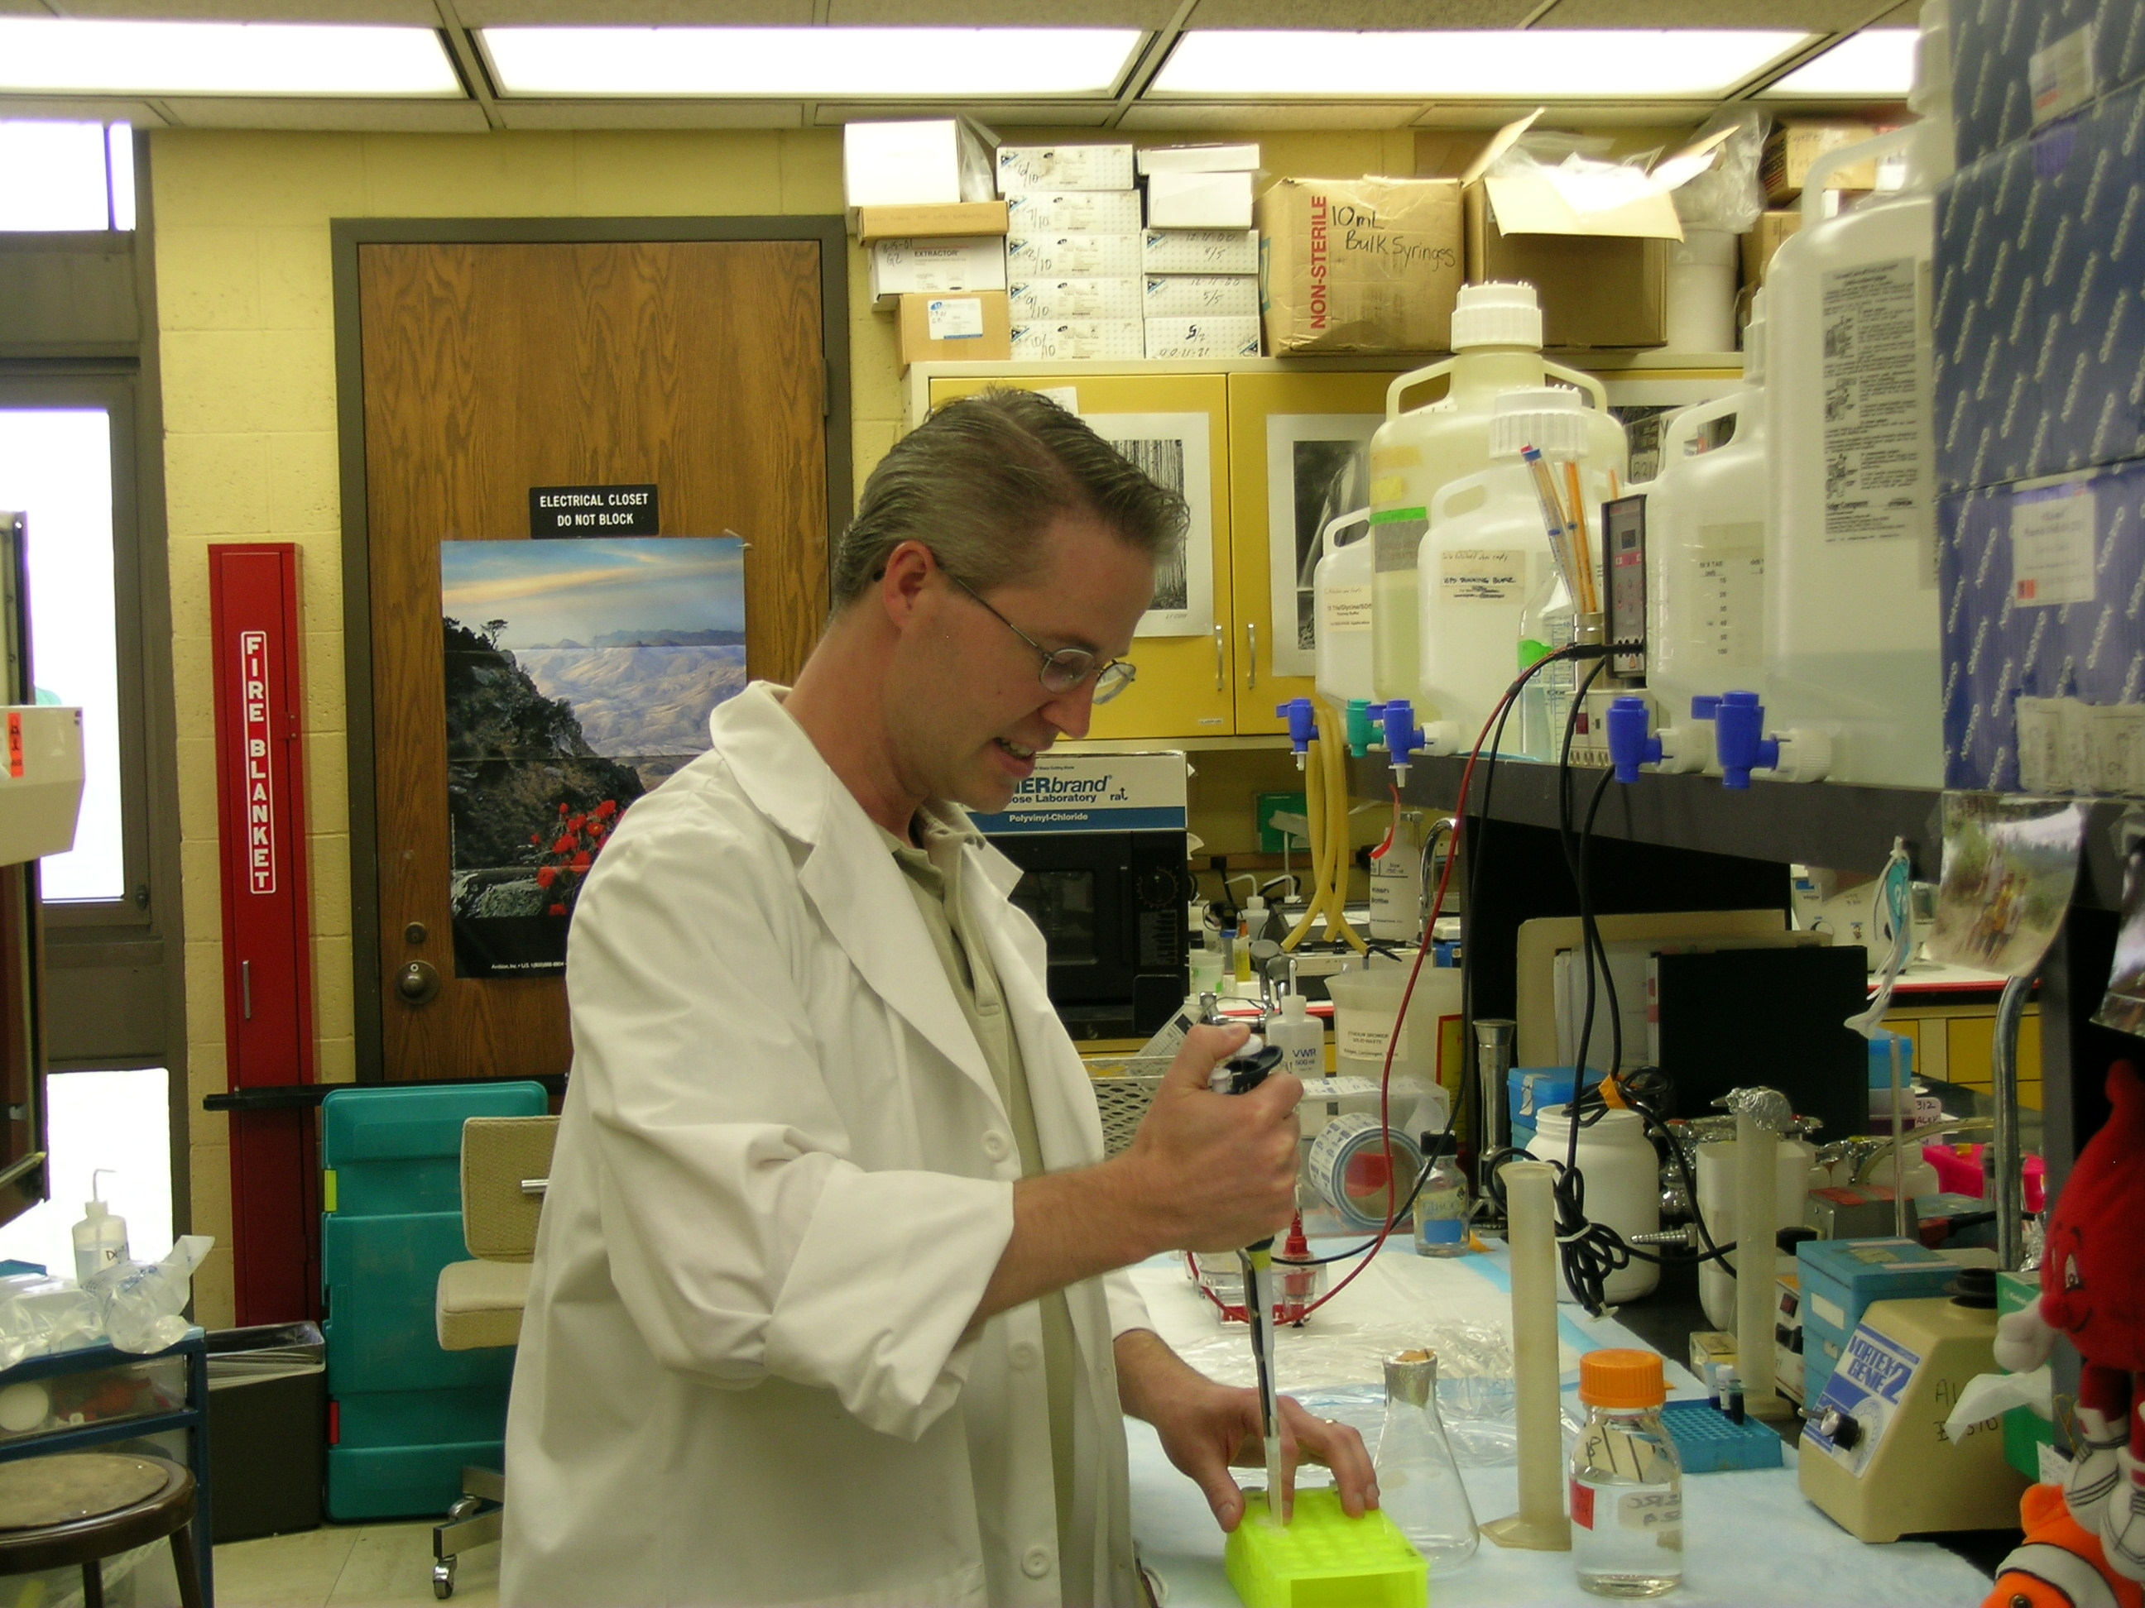
Dr. Todd Primm is the newest member of the department faculty, starting work this fall semester. He will share the microbiology teaching duties with Dr. Harold Foerster.

Dr. Primm was on the faculty of the Department of Biological Sciences at the University of Texas at El Paso for the past five years. He earned a B. S. in Biochemistry from Texas A & M and a Ph. D. in biochemistry at Baylor College of Medicine in 1997. This was followed by post-doctoral study at the National Institutes of Health. Dr. Primm’s research is focused on bacterial physiology and antimicrobial drug development. On the significance of his studies, Dr. Primm states: “As many of the readers of the Biology Newsletter will know, antibiotics are a tremendous medical advance, and have served to combat infections in patients for many years. However, the rise of multi-drug resistant bacteria is a major challenge to the continued utility of antibiotics. My lab is working on a better understanding of how certain compounds kill bacteria, with the goal of discovering new targets in bacteria and possibly new antibiotics.” Dr. Primm’s recent publications include:
CS Bland, JM Ireland, E Lozano, ME Alvarez, and TP Primm. “Mycobacterial Ecology of the Rio Grande” 71(10) Applied and Environmental Microbiology. 2005.
RJ Archuleta, PY Hoppes, and TP Primm. “Mycobacterium avium enters a state of metabolic dormancy in response to starvation” 85(3) Tuberculosis. 2005.
L Rajabi, C Courreges, J Montoya, RJ Aguilera, and TP Primm. “Acetophenones with selective antimycobacterial activity” 40(3) Letters in Applied Microbiology. 2005.

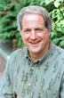
He and Dr. Kristine Garza at UTEP were awarded an R15 AREA grant from NIH, entitled "Mycobacterium avium-phagocyte interactions in a murine infection model." The period of support is from 12-1-05 through 11-30-07, with direct costs of $222,000. Dr. Primm recently served as reviewer for chapters 5-6 of the textbook “Recombinant DNA”, 3rd Ed., by James Watson, et al. published by W. H. Freeman and Company. Dr. Primm is teaching courses in Introductory Cell Biology and Introductory Applied Microbiology this fall semester. We welcome Dr. Primm to SHSU and the Department of Biological Sciences.

Dr. Matthew Rowe joined the faculty in August as Department Chair, replacing Dr. Monte Thies who has returned to full time teaching and research. Dr. Rowe has three degrees from the University of California at Davis. Upon obtaining the Ph. D. degree there in 1984 in behavioral ecology, he joined the faculty of the Department of Biological Sciences at Appalachian State University in Boone, NC. During his 21year tenure at Appalachian State, Dr. Rowe received numerous nominations and awards for excellence in teaching and mentoring, including the North Carolina Board of Governors Excellence in Teaching Award in 1999. He and his students have published extensively in the areas of predator-prey co-evolution and conservation biology. Under funding from U. S. Fish and Wildlife Service, National Geographic Society, U. S. National Forest Service, the NC Wildlife Resources Commission, and other funding sources, Dr. Rowe has conducted research on a variety of organisms, including bark scorpions, grasshopper mice, the northern saw-whet owl, timber and pygmy rattlesnakes. His most recent publications are:

Bulluck, J.F. & M.P. Rowe. (In review). The importance of southern Appalachian wetlands to breeding birds. The Wilson Bulletin.
Rowe, A.H. & M.P. Rowe. (In press). Risk assessment by grasshopper mice (Onychomys spp.) feeding on neurotoxic prey (Centruroides spp.). Animal Behaviour.
Rowe, M.P. 2004. Mimicry. Pp. 767-772 in: An Encyclopedia of Animal Behavior. M. Bekoff, ed. Greenwood Press, Westport, CT.
Swaisgood, R.R., M.P. Rowe, & D.H. Owings. 2003. Antipredator responses of California ground squirrels to rattlesnakes and rattling sounds: the roles of sex, reproductive parity, and offspring age in assessment and decision-making rules. Behavioral Ecology and Sociobiology 55:22-31.

In addition to his administrative duties, Dr. Rowe will continue his research in behavioral ecology. This semester he is teaching the General Ecology course. We welcome Dr. Rowe to SHSU and the Department of Biological Sciences.

Faculty News

Dr Everett Wilson (1962) reports the following note on his activities for the past year: “I have continued my activities in San Miguel de Allende, Mexico, recruiting students and helping with orphanage kids. I also have continued working on recruiting in Belize. I have recruited Sian Escobar's sister Tonya Escobar who enrolled at SHSU in January 2005. This past May 15th I conducted a Bio 380 Field ecology trip with 17 students to Belize. We were there for two weeks traveling the country, observing plants, animals, birds, Mayan ruins, deep sea fishing, snorkeling, scuba diving in Hol Chan marine reserve, and received lectures by the environmental commissioner on pollution and waste disposal problems in the country. It was a great course, receiving excellent reviews from students. I will be conducting the same course again next May to begin at the end of the spring term and completing before the start of the first summer session. The following are publications this past year.

Escobar, Sian A.,Wilson, Everett D., Lutterschmidt, William I., and Etheredge, Gerry. A Morphometric Analysis of Hybrid Box Turtles From East Texas With Notes on Early Reproduction. A Poster Presentation at the annual Meeting of the Texas Academy of Science, March 2005
Lutterschmidt, William I., Turk, Sara B., and Wilson, Everett D. 2005 Seasonal Timing Of Follicular Development Of The Mud Snake, Farancia abacura (Colubridae). Herpetological Review 36(3), 244-248.
Lutterschmidt, William I., Escobar, Sian A., and Wilson, Everett D. 2005 Multivariate Analysis of Shell Morphology in Hybrid Box Turtles. Manuscript submitted to The Texas Journal of Science.

This fall semester, his 43rd at SHSU, Dr. Wilson is teaching courses in Human Physiology, Vertebrate Embryology, and Endocrinology.

Dr. Justin Williams “This has been an eventful year for Dr. Williams. He is the Principle Investigator on a USDA funded program to monitor the effects of water quality along the Rio Grande. Together with Dr. Lutterschmidt (Co. P.I.), they are studying the effects of land coverage on water quality as measured by fish diversity. Second year funding has been approved and to date the project has generated 250k in funds for the department. Williams P. Spencer, an undergraduate student in Dr. Williams' lab, co-authored a presentation with Justin on the Invasive Plant Species of Texas. The poster presentation won first prize (out of a pool of 100) in undergraduate research at the annual meeting of the American Society of Horticultural Sciences held in Las Vegas, Nevada this past July. Justin also spent a week this July at the Gray Herbarium in Harvard collaborating on an upcoming phylogeny of the Apocynaceae, his model organism. After the trip to Cambridge, Justin spent two weeks with his graduate student, Steven Koether, collecting various Apocynaceae in Mexico as part of the on going work in the phylogenetics of the Apocynaceae. Dr. Williams is also completing his second year as editor of Phytologia, the oldest plant systematic journal in the U.S. He has submitted for review four articles this year and has presented data at four conferences. Most importantly, Justin and Jennifer are expecting their first child due the first week of November.”
Dr. Williams teaches courses in Classification and Natural History of Plants, Plant Taxonomy, General Botany and, this semester, a new graduate course in Applied GIS (Geographic Information Systems) for Biologists.

Dr. Tami Cook (2000) won tenure this past year and was promoted to Associate Professor. She and her students continue to be active in research. Two of her graduate students, M. Brandon Lowery and Autumn J. Smith, completed their M. S. degrees in August. Both students presented their thesis research at meetings of the American Society of Parasitologists, Southwestern Association of Parasitologists, and Texas Academy of Science. Undergraduate students in Dr. Cook’s lab, Sabrina Dahlgren, Shannon Rodriguez, Ashley Black and Whitney Cox, also presented talks at meetings of the American Society of Parasitologists or the Southwestern Association of Parasitologists. Dr Cook and her students, along with collaborators Dr.’s J.L. Cook and R.E. Clopton, continue work on a National Science Foundation grant “Collaborative Research: Microbiological Survey and Inventory of Gregarines Parasitizing Aquatic and Riparian Insects of the Texas Big Thicket”. This grant was awarded under NSF’s RUI (Research in Undergraduate Institutions) program and was funded in the amount of $232,854 for 2004-2007. The investigators were recently awarded $24,172 in supplemental funding to bring Dr. Ralene Mitschler to our campus for six weeks in the fall of 2005 to collaborate on the gregarine survey. Dr.’s Tami and Jerry Cook continue work on the three year $100,000 grant from the Texas Army National Guard, Environmental Resources Management Branch- “Release and Attempt to Establish Natural Enemies of the Red Imported Fire Ant.” Also, during this past year, Dr. Cook was elected President, Southwestern Association of Parasitologists, was a member of NSF Biotic Surveys and Inventories Grant Review Panel (Oct ’04 & ‘05), and on campus, she was named to the University Research Council, the College of Arts & Sciences dean search committee and to the Elliot T. Bowers Honors Program Council. Dr. Cook’s teaching assignments include Parasitology, Invertebrate Zoology, General Ecology and General Zoology.

During this past year Dr. Jerry Cook (2000) was tenured and promoted to Associate Professor. He was elected to offices in two professional societies, Academic Advisor for the Texas Academy of Sciences and Secretary/Treasurer for the Southwestern Association of Parasitiologists. Two of Dr. Cook’s graduate students completed their Master’s degrees, Kc Wendler and Melissa Layton. Kc is working in Colorado and Melissa has begun a Ph.D. program at Texas A&M University. Dr. Cook and his students published three articles in peer-reviewed journals:

Derr, D. P. and J. L. Cook. 2005. Morphology of the antennae of Caenocholax fenyesi Pierce (Strepsiptera: Myrmecolacidae) based on scanning electron microscopy. Proceedings of the Entomological Society of Washington, in press.
Reeves, W. K. and J. L. Cook. 2005. First record of Triozocera vernalis Kifune and Brailovsky (Strepsiptera: Corioxenidae) from the United States, with additional records for Strepsiptera in South Carolina. Entomological News, 116(3):191-192.
Cook, J. L., L. A. Calcaterra, and L. Nuñez. 2004. First record of Caenocholax fenyesi (Strepsiptera: Myrmecolacidae) parasitizing Solenopsis invicta (Hymenoptera: Formicidae) in Argentina with a discussion on its distribution and host range. Entomolgical News, 115(2): 61-66.

Dr. Cook gave presentations at four scientific conferences, served on a grant panel for the National Science Foundation, and was a recipient of ten grants and contracts. On two of the larger grants he and Dr. Tami Cook are co-investigators: National Science Foundation grant “Collaborative Research: Microbiological Survey and Inventory of Gregarines Parasitizing Aquatic and Riparian Insects of the Texas Big Thicket” ($232,854) and the Texas Army National Guard, Environmental Resources Management Branch- “Release and Attempt to Establish Natural Enemies of the Red Imported Fire Ant.” ($100,000) He also has committed to writing a book on Forensic Entomology to be published by Prentice Hall. Dr. Cooks teaches a diverse set of courses for the Department including Histology, Economic Entomology, Forensic Entomology, General Zoology, Human Biology (BIO 341) and Ichthyology.

Dr. Ted Brummel (2004) is in his second year with the Department. He teaches courses in Introductory Genetics, Advanced Genetics and Introductory Cell Biology. Dr. Brummel is pursuing his research interests developed while working as a post-doctoral student with Dr Seymore Benzer at Cal Tech. He is studying the genetics of aging, examined in the model organism, Drosophila melanogaster. He was an author of two articles on this subject last year:

DeVeale, B., T, Brummel, and S. Laurent (2004) Immunity and aging: the enemy within? Aging Cell 3 (4), 195-208.
Brummel, T., Ching, A., Seroude, L.S., Simon, A.F. and Benzer, S. (2004) "Drosophila lifespan enhancement by exogenous bacteria" Proc. Natl. Acad. Sci. U. S. A. 101: 12974-9.

The later article was referenced by over 20 U. S. newspapers and was selected for review in The Faculty of 1000, which is an online research service that reviews the most interesting papers published in the biological sciences, based on the recommendations of over 1000 leading researchers. Dr. Brummel researched the lifespan of Drosophila under axenic conditions and standard conditions, and found that the presence of bacteria during the first week of adult life can enhance longevity as much as 30%.. Later in life, the presence of bacteria can reduce lifespan. Certain long-lived mutants react in different ways, indicating an interplay between bacteria and longevity-enhancing genes. The university awarded Dr. Brummel a Research Enhancement Grant to continue his research at SHSU.

Dr. Anne Gaillard (2004) is beginning her second year in the Department as cell biologist. This past year she received a $15,000 grant from the Texas Excellence Fund. This funding has been used to support Dr. Gaillard’s current research project which involves investigating the role of a protein kinase in the regulation of flagellar motility (using Chlamydomonas as a model organism). She will present the initial findings of this study at the American Society for Cell Biology annual meeting, which is to be held this December in San Francisco. Over the past year, an undergraduate student, Brandy Verhalen, worked with Dr. Gaillard on this project. Brandy graduated from SHSU this past May, and this fall, she entered a PhD program in cell biology at the State University of New York (SUNY) Upstate, in Syracuse, NY. Dr. Gaillard and husband recently relocated from Cypress, TX, to The Woodlands area, which will reduce her commuting time significantly. This fall she is teaching the senior level Cytology course and a graduate course, Cell Structure and Physiology.

Dr. Jack Turner (1983) was promoted to full professor this past spring semester. Dr. Turner continues his research interest in the Bighorn Sheep populations of Southern California. He is the lead author of a recent, significant study in this area “Determination of critical habitat for the endangered Nelson’s bighorn sheep in southern California”, Jack C. Turner, Charles L. Douglas, Cecil R. Hallum, Paul R. Krausman and Rob Roy Ramey, Wildlife Society Bulletin, 32(2):427-448. The objective of the study was “to quantify Nelson’s bighorn sheep habitat in the northern Santa Rosa Mountains, identify those parcels of land having the greatest potential and probability for occupancy, and compare this to USFWS (2001) critical-habitat designation.” Their findings indicated that large parcels of land designated by USFW as critical habitat for this species are not utilized by bighorn sheep. You may read the article for their conclusions. Dr. Turner continues to teach the General Physiology course and the Fish, Wildlife and Recreation Management course. This semester he is teaching two internet-based courses, Contemporary Biology and Pathophysiology.

Dr. Monte Thies (1992) was also promoted to full professor and stepped down as department chair to get more involved in teaching and research. “Two of my students completed their MS degrees over the past year. Caprice Coleman finished up on her molecular study of Mexican free-tailed bats and is now teaching in Oklahoma. Anica Debelica completed her project that focused on identification of hair from Texas land mammals. She presented her research at several meetings, including the American Society of Mammalogists, which has already led to a collaborative project with a team of archaeologists from Idaho. My second REU student, Steven Rhoels from Calvert College, Michigan, looked deeper into the effectiveness of using chemical repellents to prevent fire ants from killing rodents in our small mammal population work. His results were outstanding, and we hope to have a manuscript submitted for publication later this fall. Our progress on developing the laboratory for examining West Nile Virus in mosquitoes from the Rio Grande Valley has been slow, but equipment has been trickling in, and we’ve been able to get some results. The butterfly work has also progressed well, with the completion of two new shade structures at the field station, one as a flight/breeding facility and one as a “recovery ward” for plants eaten down to the stem by hungry caterpillars. It’s also been a good (yet also very sad) year for collaborations with the Houston Zoo for obtaining teaching material in that we were able to acquire a Siberian tiger, snow leopard, mountain lion, and a number of other specimens through the zoo veterinarian. Many of these specimens have been prepared for use in various classes and programs.”

Dr. Diane Neudorf (1999) “I continue to conduct research on extra-pair mating behavior of forest-nesting songbirds at the Center for Biological Field Studies. My research projects and those of my students are focused on two common species at the field station, the Carolina Wren and the Northern Cardinal. Additional projects I have managed this year include an avifaunal survey of Fort Wolters, a training area for the Texas Army National Guard, located in Mineral Wells, TX and a species assessment of the Lark Bunting for the USDA. This summer Dr. Lutterschmidt and I again ran the NSF supported Research Experiences for Undergraduates in Experimental Field Biology at Sam Houston State University Program. Six students from colleges in Michigan, Ohio, Maryland, Pennsylvania and Texas spent 10 weeks living on our campus and working on independent research projects with biology faculty mentors. The students enjoyed field trips to the Houston Museum of Natural Science, the Houston Zoo, Moody Gardens, the Festival Institute at Roundtop and the University of Texas Marine Science Institute in Port Aransas. The students presented their research in a poster conference at the LSC at the end of the summer. Many of the students plan to present their research at national conferences in the coming year. I attended the American Ornithologists’ Union (AOU) meeting in August with 2 of my graduate students (Sheena Humbird and Guadalupe Quiroz). The meeting was held on the beautiful University of California – Santa Barbara campus. We each gave a poster presentation of our research. I served on the Student Research Award Committee for the AOU again this year and judged several student papers for awards. I received several honors this year. The most exciting was that I was promoted to Associate Professor in the Department of Biological Sciences and received tenure. I was also elected to new positions in two Professional Societies. I am now Chair of the Terrestrial Ecology Section for the Texas Academy of Science and an Elective Member of the AOU, an honor bestowed in recognition of contributions to the field of Ornithology”.
Honors and Awards of my students:
Guadalupe Quiroz, MS Candidate obtained a travel award from the American Ornithologists’ Union to attend the annual meeting in Santa Barbara, CA in August.
Sheena Humbird, MS Candidate, obtained a Sigma Xi Student Research Grant to support her research on extra-pair mating behavior in Northern Cardinals.
Presentations:
Humbird, S. K. and Neudorf, D.L.H. 2005. Extra-pair mating tactics in female Northern Cardinals: a test of the constrained female hypothesis. Presented at the 123rd meeting of the American Ornithologists’ Union. Aug. 23-27, University of California, Santa Barbara.
Neudorf, D.L.H. 2005. Avifaunal survey of a National Guard training site within the Post Oak Savannah ecoregion of Texas. Presented at the 123rd meeting of the American Ornithologists’ Union. Aug. 23-27, University of California, Santa Barbara.
Quiroz, G. and Neudorf, D.L.H. 2005. Nest vigilance by male Carolina Wrens during incubation. Presented at the 123rd meeting of the American Ornithologists’ Union. Aug. 23-27, University of California, Santa Barbara., and at the 52nd Annual Meeting of the Southwestern Association of Naturalists. Apr. 14-16, 2005. Sam Houston State University.
Ramon, P. A. and Neudorf, D.L.H. 2005. An investigation of the use of song and territory in paternity guarding behavior of the Carolina Wren. Presented at the 4th Annual Student Research Conference. April 8, 2005, University of Houston Downtown , and at the . American Association for the Advancement of Science Annual Meeting. Feb. 17-21, 2005. Washington.
Neudorf, D.L.H. 2005. An inventory of birds at Fort Wolters training area. 52nd Annual Meeting of the Southwestern Association of Naturalists. Apr. 14-16, 2005. Sam Houston State University.

Dr. Karolis Bagdonas. “The summer of 2005 was again very busy. On June 23, 2005, I gave an invited seminar to over 130 researchers at the University of Wyoming/ National Park Service Research Center at Jackson Lake in Grand Teton National Park. The title of the Summer Research Series seminar was “Feeding Strategies of Grizzly Bears in Northwestern Wyoming Wilderness Areas.”
I also presented a paper at the 56th Annual Meeting of the International Lepidopterists’ Society in a joint meeting of the Pacific Slope Section Of the Lepidopterists’ Society and the Southeastern Arizona Chapter of the North American Butterfly Association held in Sierra Vista, Arizona August 1-7, 2005. My talk was on August 4 and was titled “Where Have All the Lepidoptera Gone? The Strange Summer of 2004 in Northwestern Wyoming."
I also collaborated with Dr. George Stevenson, a Professor of Neurology at the University of Florida who was in Wyoming for the summer. He has asked me to write a chapter in his book on the Neurology of Grizzly Bears. Specifically, my chapter is on the grizzly behavior in changing feeding strategies on various species of moths in the Greater Yellowstone Ecosystem.
And again, Dr. Darrell Hall, retired SHSU Biology Professor, and his wife Gay visited in June for their annual week of fishing and relaxing in Wyoming. Following their visit, Mr. Frank Krystyniak, Director of Public Relations at SHSU, and his wife Linda, visited the first week in July to work on a story on our research at the Wyoming field station.”

Retired Faculty from Department of Biological Sciences and Years Served (Current Location)

Dr. Ruth Thomas1964-91 (Huntsville) Dr. Robert Stewart 1959-60, 1967-92 (Nacogdoches)
Dr. Terrell Hoage 1968-97 (Huntsville) Dr. Ralph Moldenhauer 1968-98 (Dubois, WY)

Dr. Darrell Hall 1965-98 (Huntsville) Dr. Thomas Meade 1965-99 (Tucson, AZ)

Dr. Jimmie Long 1959-99 (Huntsville) Dr. John Hilliard 1968-95 (Huntsville)
Dr. Maynard Yoes 1961-1985 (Mimbres, NM) Dr. Andrew Dewees 1967-2004 (Huntsville)

Photos from Department of Biological Sciences Homecoming BBQ
October 8, 2005

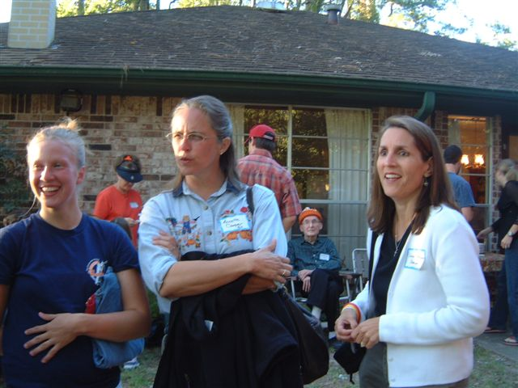 | 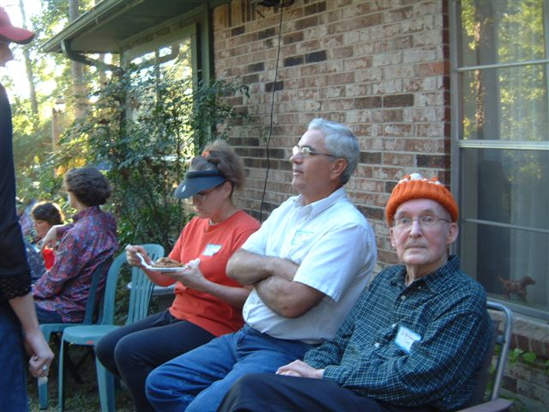 | 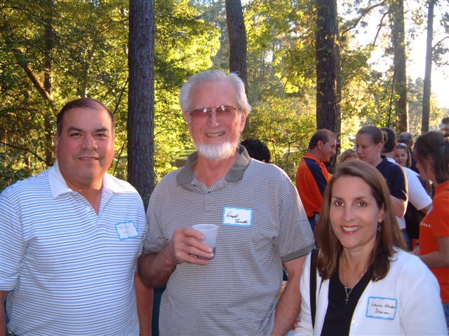
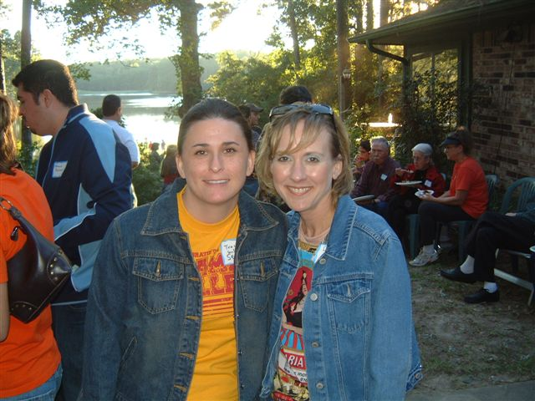 | 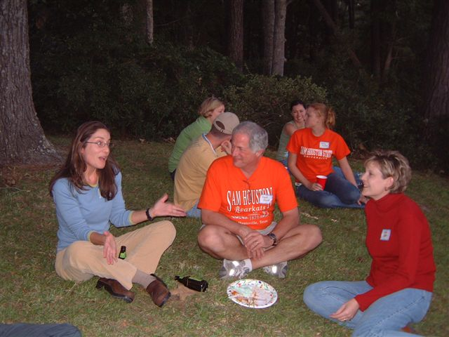 | 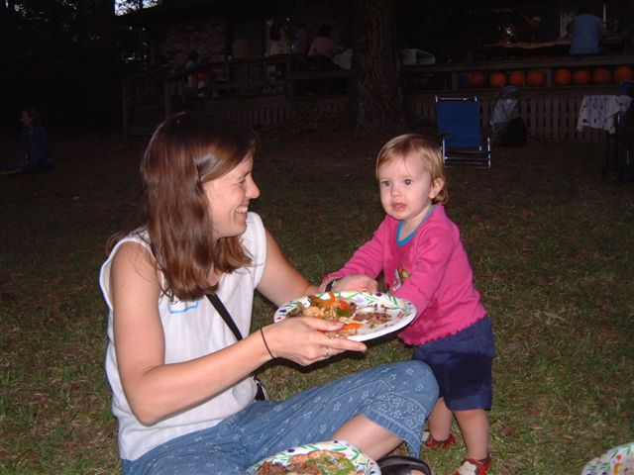
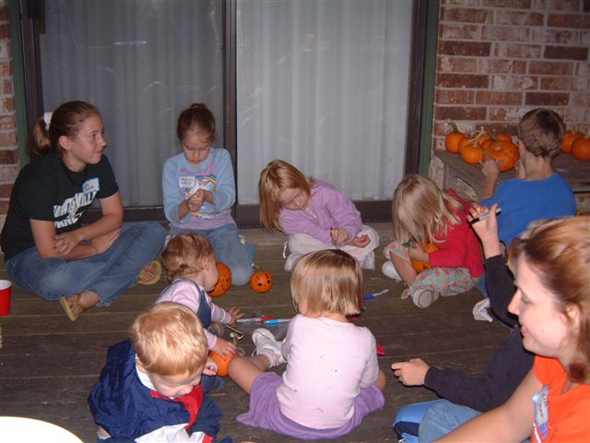 | 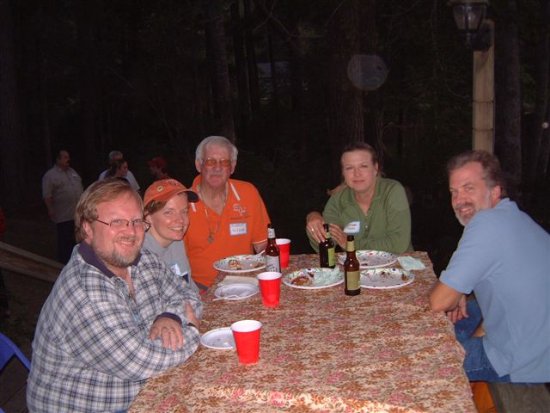 | 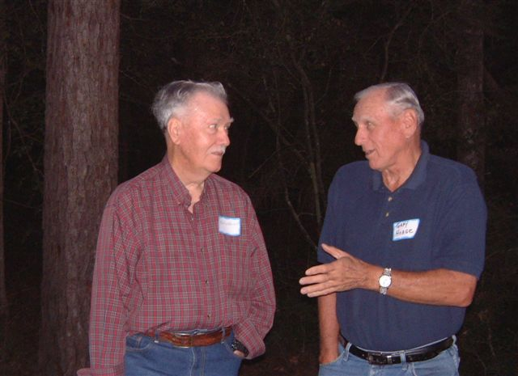
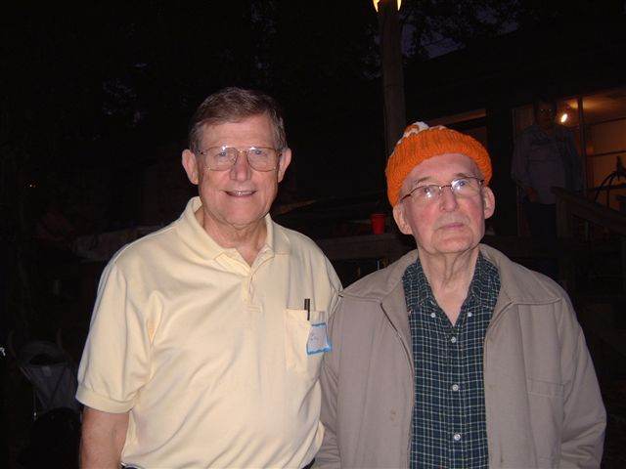 | 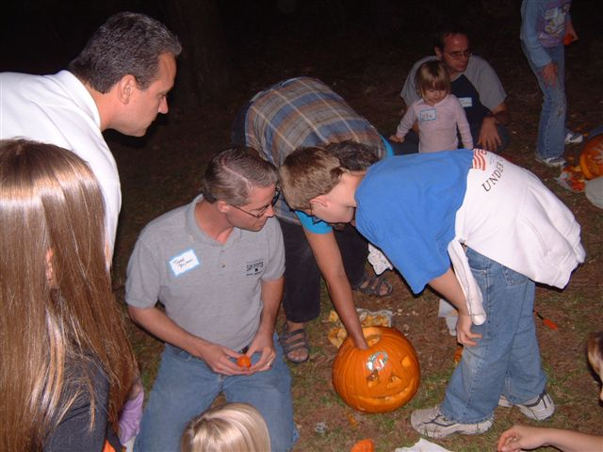 | 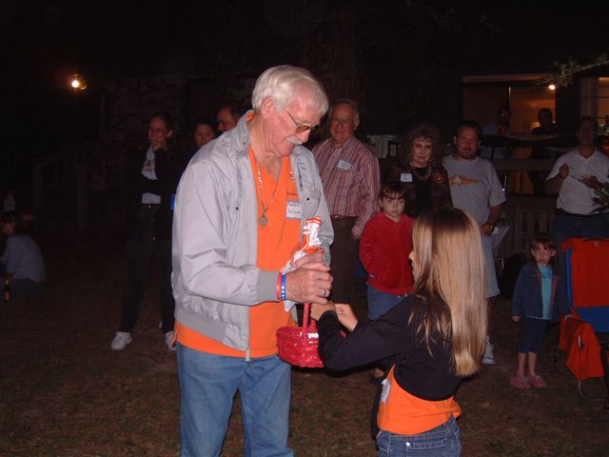
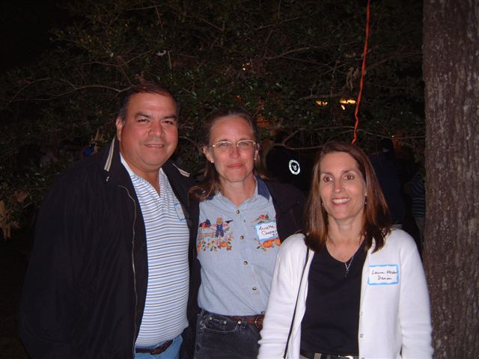 | 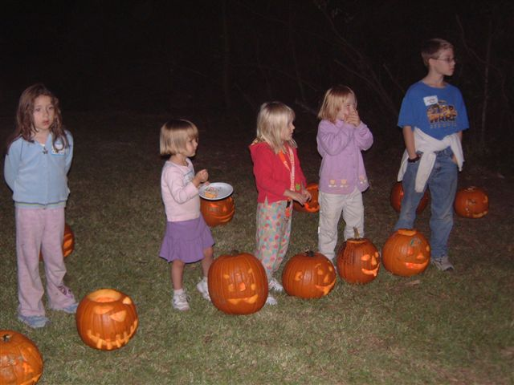 | 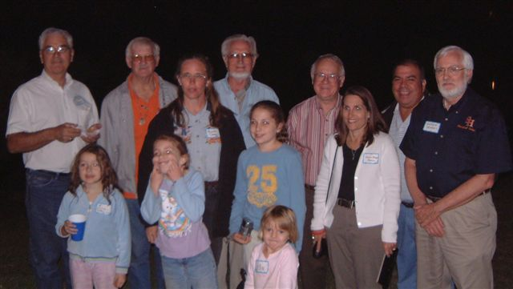

Current Faculty in Department of Biological Sciences

Matthew Rowe, Ph. D. (University of California, Davis). Professor and Chair. Behavioral Ecology mpr002@shsu.edu

Karölis R. Bagdonas, Ph.D. (Colorado State University), Associate Professor. Human Anatomy, Ecology and Entomology. bio_krb@shsu.edu
Theodore J. Brummel Ph.D. (University of California, Irvine), Assistant Professor. Genetics and Molecular biology. bio_tjb@shsu.edu
Jerry L. Cook, PhD. (Texas A&M University), Associate Professor. Entomology, Anatomy and Physiology. bio_jlc@shsu.edu
Tamara J. Cook, PhD. (Texas A&M University), Associate Professor. Entomology, Invertebrate Zoology, Parasitology and Ecology. bio_tjc@shsu.edu
James R. DeShaw, Ph.D. (Texas A&M University), Professor. Environmental Science. bio_jrd@shsu.edu
Harold F. Foerster, Ph.D. (University of Texas), Professor. Microbiology and Virology.
Anne Roush Gaillard Ph.D. (Emory University), Assistant Professor. Cell Biology and Genetics. bio_arg@shsu.edu
Joan E. Hudson, Ph.D. (Iowa State University), Associate Professor. Plant Morphology and Plant Physiology. bio_jxn@shsu.edu
James D. Long, Ph.D. (University of Texas), Professor Emeritus. Medical Entomology. bio_jdl@shsu.edu
William Lutterschimdt, Ph.D. (University of Oklahoma), Associate Professor. Comparative physiology, Physiological ecology, Herpetology. bio_wil@shsu.edu
Diane Neudorf, Ph.D. (York University), Associate Professor. Avian Biology and Animal Behavior. bio_dln@shsu.edu
Todd Primm, Ph. D. (Baylor College of Medicine). Assistant Professor. Bacterial Physiology. tpp001@shsu.edu
Monte L. Thies, Ph.D. (Oklahoma State University), Professor. Ecological and Systematic Studies of Mammals. bio_mlt@shsu.edu
Jack C. Turner, Ph.D. (University of California-Riverside), Professor. Physiological Animal Ecology. bio_jct@shsu.edu
Justin K. Williams, Ph.D. (University of Texas at Austin), Assistant Professor. Plant Taxonomy and Systematics. bio_jkw@shsu.edu
Everett D. Wilson, Ph.D. (Purdue University), Professor. Mammalian Reproduction and Endocrinology. bio_edw@shsu.edu

Alumni News and Address Correction
Notice of The Biological Sciences Newsletter is mailed annually to former students of our Department. Be sure we have your correct address. Print this page and return alumni news items soon so that we can include them in the next newsletter. Or, simply email this information to Dr. Matthew Rowe at mpr002@shsu.edu . We want to hear from you!

Name:________________________________________________________________________
First M.I. Last (Maiden)

Degree: ______ Year:_____ Major:________________________

Current Address: ___________________________________________________________
___________________________________________________________
___________________________________________________________

Telephone Number(s): ___________________________________________________________

Email Address: _________________________________________________________________

Current Employment, news of your family and activities:

_____________________________________________________________________________

_____________________________________________________________________________

_____________________________________________________________________________

_____________________________________________________________________________

_____________________________________________________________________________

_____________________________________________________________________________

Please Return by US Mail To:
Dr. Matthew Rowe, Chair
Department of Biological Sciences
P.O. Box 2116
Sam Houston State University
Huntsville, TX 77341-2116

Or Email: mpr002@shsu.edu Or FAX 936-294-3940

This Newsletter is also posted on the Department’s website: www.shsu.edu/~bio_www/
(Newsletter Editor A. Dewees, bio_aad@shsu.edu)

