Outdoor Annual → Fishing → Freshwater Fishing → Catfish Identification

Catfish Identification

Channel Catfish
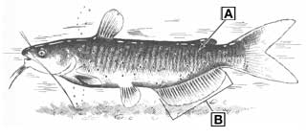
Channel Catfish
- A: Body with dark spots (spots may be absent in large adults)
- B: Outer margin of anal fin rounded, and anal fin with 24 to 29 rays
More about channel catfish

Blue Catfish
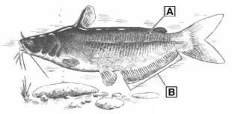
Blue Catfish
- A: Body without dark spots
- B: Outer margin of anal fin straight, and anal fin with 30 to 36 rays
More about blue catfish

